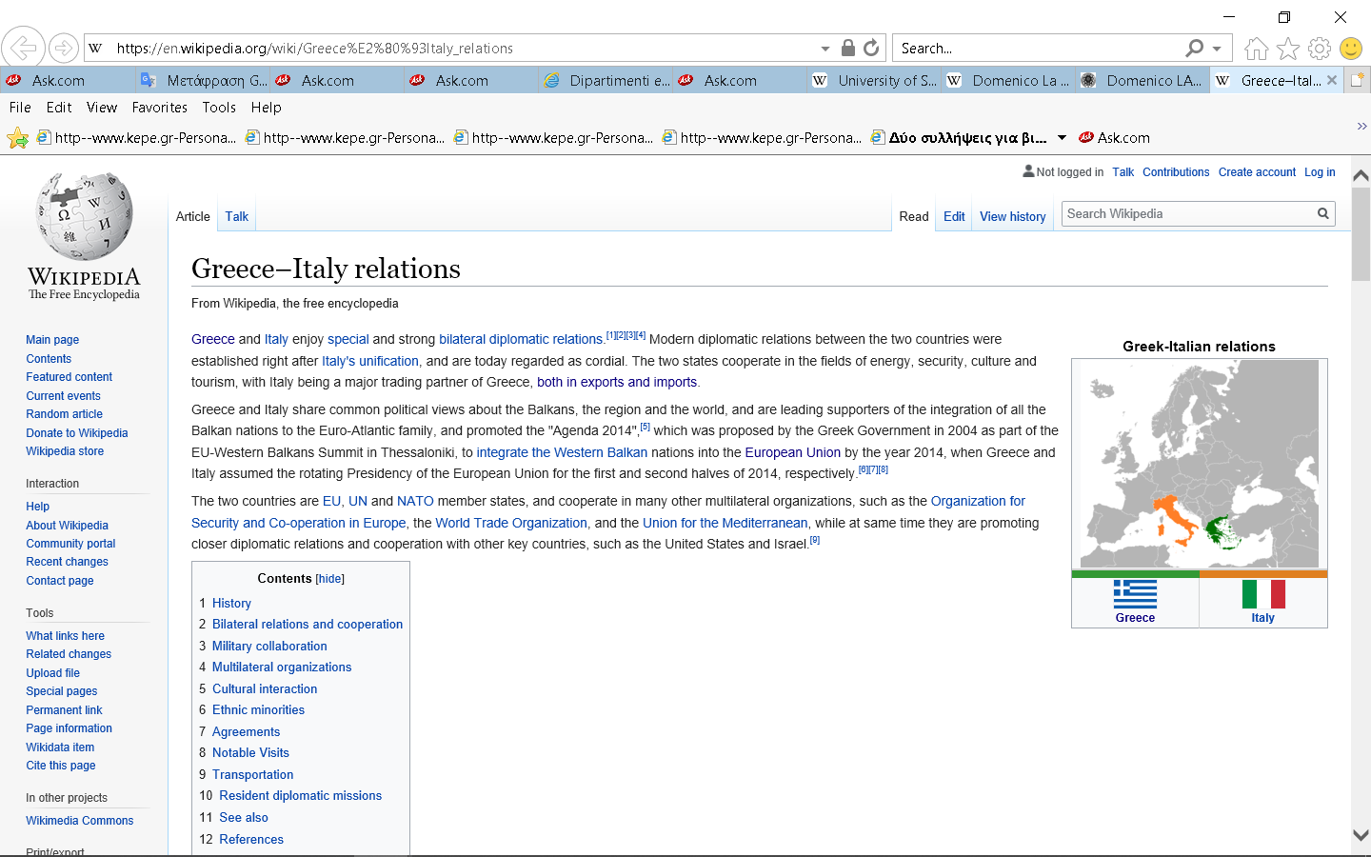
Greece-Italy
Special Issues in Entrepreneurship & Innovation (2020), pp.00-00

Author Guidelines

Authors’ Names
Affiliation
e-mail address

Abstract
The present text describes the format of articles published in the special volume. The format of this file follows the typewriting guidelines described therein.

Keywords: Please provide the keywords related to the manuscript.
1. Introduction
All submitted papers should adhere to the following guidelines. Papers that do not comply with these guidelines will not be considered for publication.
Authors should prepare manuscripts in MS Word 2000/2 or 2003. The Times New Roman font family must be used throughout the manuscript.
Manuscript components should be arranged as follows:
- Title: written in bold, size 16pt., centered and using Title Upper Case format
- Two (2) blank lines
- Names of the authors written in 11pt. size, centered followed by Affiliations and e-mail addresses
- One (1) blank line
- The word ‘Abstract’ in bold, 11pt font size
- Abstract text in 10pt. font size
- Keywords must appear one line after the abstract in 10pt fonts.
- One (1) blank line
- Main body text (including section titles as described below).
All blank lines are in 11pt normal. Note that there are no blank lines anywhere else in the text.
2. Main Text
2.1 Page Setup
The author must use the following specifications for page setup (File → Page Setup).
[MARGINS]
Top: 2 cm Bottom: 2 cm
Inside: 1,8 cm Outside: 1,8 cm
Gutter: 0 Gutter Position: Left
Multiple Pages: Mirror Margins
[PAPER]
Paper Size: Custom Size
Width : 17 cm
Height : 24 cm
[LAYOUT]
Section Start : New Page
Headers and Footers :
Different Odd and Even → Checked
Different First Page → Checked
From Edge :
Header : 1,8 cm
Footer : 1,5 cm
2.2 Body Text
Body text must be written in 11 pt font size. In the paragraphs’ format you must use 6pt spacing after (each paragraph).
If a paragraph contains
- Bullets
- Numbered cases e.g. (a), (b), (c), or (i), (ii), (iii) etc.
- Other elements
belonging to the same paragraph, they must not have any additional spacing between them.
The sections’ title (e.g., 1. INTRODUCTION) uses 12pt bold font size with 0pt spacing before and 6pt spacing after. Do not use Automatic Numbering anywhere in the text.
2.3 Paragraphs
The subsections’ title uses 11pt bold font size with 0pt spacing before and 6pt spacing after. Avoid using third level headings (e.g. 2.1.1). If this is absolutely necessary, third level headings should be written in 11pt bold fonts.
For further text numbering, the authors are free to use any bullet and numbering style e.g. (a), (b), (c) or (i), (ii), (iii) etc. Please do not use automatic numbering.
FOOTERS ARE NOT ALLOWED.
2.4 Equations
Mathematical equations which are not built-in a text line, should be centered in a separate line and must be considered as a separate paragraph. The equation numbers should be placed in the right margin.
(1)
2.5 Figures and Tables
All figures and tables should be numbered. Figure and table captions should appear on the top and they should have 6pt spacing above and below.
Figure 1. Description Text
Source: Ιf any.
Table 1. Description Text
Sample Table | Sample Table
Sample Text | Sample Text
Source: Ιf any.
Tables’ text is the same as the body text.
All figures and tables will be printed in black and white. Author must choose appropriate colors, which are well-contrasted in a black & white print. We do not change colors.
Figures and tables should lie within the printable page area. If there is a large figure or table that should appear in landscape, then a new section must be created for it without header.
Problems often occur when special software is used for the creation of graphics. Please use standard tools for this purpose.
2.6 Headers
Retain the headers of this script. The right headers and page numbers will be inserted at the publication stage.
2.7 References
References should be cited in the text in brackets with the author’s name and the year, e.g. (Anderson et al., 1988). If you opt to include the author's name(s) in a sentence, you may site as follows: “According to Anderson et. al. (1996)”, or “Anderson et al. (1996) suggest ....” or “The examples given by Efron and Hastie (2016) are ..."
At the end of the paper, the references should appear in alphabetical order, using the format below.

Acknowledgments: Please provide acknowledgments if applicable.
References
Aziz N.A.B., Moin N.H. (2007). Genetic algorithm based approach for the multi product multi period inventory routing problem. In Proceedings of 2007 IEEE international conference on industrial engineering and engineering management. Singapore (pp. 1619-1623).
Bardi M., Mortagy A., Alsayed A. (1998). A multi-objective model for locating fire stations. European Journal of Operations Research, 110: 243-260.
Efron B., Hastie, T. (2016). Computer Age Statistical Inferece, Cambridge: Cambridge Univ. Press.
Yang Z., Emmerich M., Bäck T., Kok, J. (2015). “Multicriteria inventory routing by cooperative swarms and evolutionary algorithms.” In J. M. Ferrández Vicente, J. R. Álvarez-Sánchez, F. de la Paz López, J. Toledo-Moreo and H. Adeli (Eds.), Bioinspired computation in artificial systems. New York: Springer, 127-137.

Examples of conference paper, article, book, chapter in a book.

